**Exploratory Data Analysis**

1. We are Using the data from Canadian Institute for Cybersecurity (CIC) project funded by Canadian Internet Registration Authority (CIRA) data set <https://www.unb.ca/cic/datasets/dohbrw-2020.html>
2. It has 3 different data set Non-DoH, malicious DoH, Bengine DoH so we merged those data. The Non-DoH and Bengine data is generated by using the simulated web browsers and the Malicious DoH is generated by using the combination of tools used to create DoH tunneling.
3. Importing data
   1. Loaded the data using the python library pandas and display the data set information using the shape(), info(), describe() functions.

* 1. Checking for null values duplicate values and removing if there are any.

* 1. Visualization

sns.violinplot(data=df, x="FlowBytesReceived", y="Label", scale="count")

sns.violinplot(data=df, x="PacketLengthMean", y="Label", scale="count")

sns.violinplot(data=df, x="PacketLengthVariance", y="Label", scale="count")

sns.boxplot (data=df, x="FlowBytesReceived", y="Label", scale="count")

sns.boxplot(data=df, x="PacketLengthMean", y="Label", scale="count")

sns.boxplot(data=df, x="PacketLengthVariance", y="Label", scale="count")

sns.histplot(data=df, x='Duration', hue='Label')

sns.histplot(data=df, x='ResponseTimeTimeSkewFromMedian', hue='Label')

sns.kdeplot(data=df, x="PacketLengthVariance", hue="Label")

* 1. Co-relation

Co-relation between the malicious-DoH and features

Corelation between Bengine DoH

Corelation for Non-DoH.

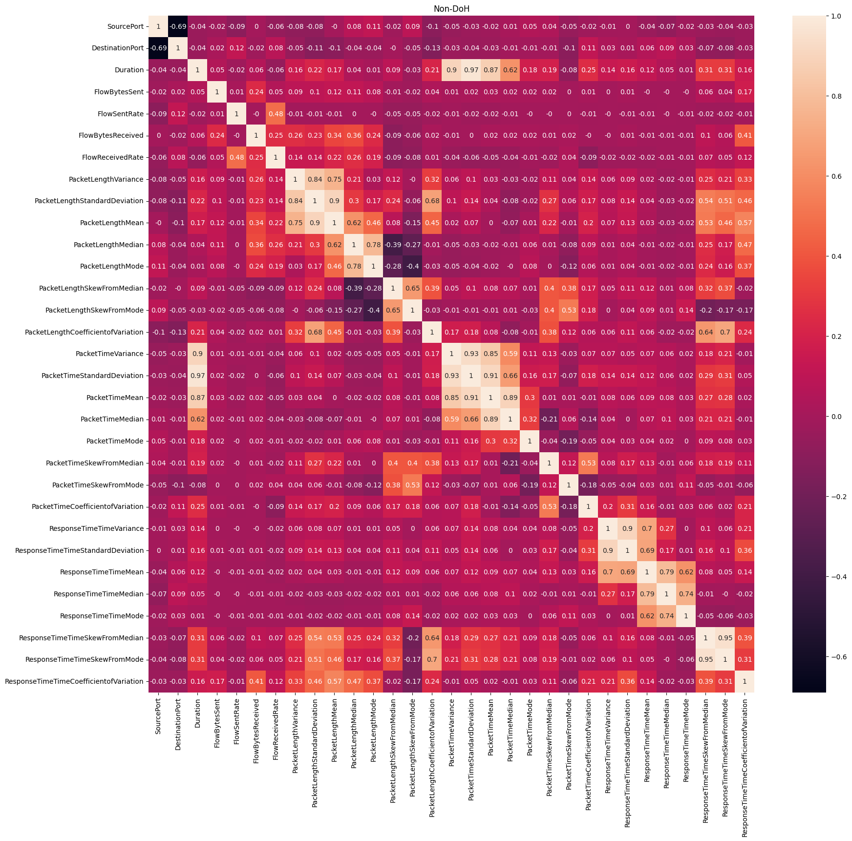

* 1. Outliers

* 1. Data training

